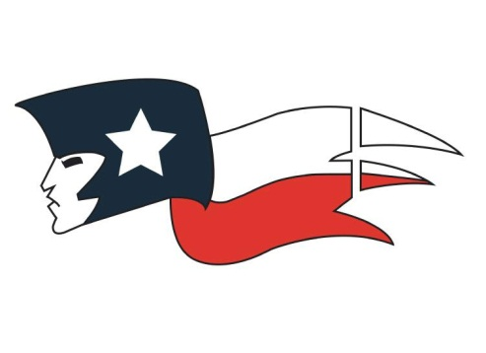
Shack PE Curriculum

*All JH TEKs are in link on my web page

August 27th-August 28th
Learning Obj: SWBAT understand and apply PE expectations for the upcoming year via implementing PBIS Pride concepts.
Activity: PE Syllabus and PBIS Pride concepts.
Assessment: Hand Symbols

August 29th-September 7th
Learning Obj: SWBAT develop kinetic, cognitive, social, and emotional skills while actively participating in various team sports.
Activity: Beach Volleyball progress to Volleyball (Girls); Patriot Ball progress to Flag FB (Boys)
Assessment: 70%-Participation 30%-Suit Out

September 10th-September 28th
Learning Obj: SWBAT develop kinetic, cognitive, social, and emotional skills while actively participating in various team sports.
Activity: Matt Ball progress to Wiffle Ball
Assessment: 70%-Participation 30%-Suit Out

October 1st-October 8th
Learning Obj: SWBAT develop kinetic, cognitive, social, and emotional skills while actively participating in various team sports.
Activity: Fort Knox
Assessment: 70%-Participation 30%-Suit Out

October 9th-November 2nd
Learning Obj: SWBAT develop kinetic, cognitive, social, and emotional skills while actively participating in various team sports.
Activity: Hand Ball progress to Korf Ball
Assessment: 70%-Participation 30%-Suit Out

November 5th-November 30th
Learning Obj: SWBAT develop kinetic, cognitive, social, and emotional skills while actively participating in various team sports.
Activity: Jailhouse Basketball progress to Numbers Basketball
Assessment: 70%-Participation 30%-Suit Out

December 3rd-December 18th
Learning Obj: SWBAT develop kinetic, cognitive, social, and emotional skills while actively participating in various team sports.
Activity: Patriot Basketball
Assessment: 70%-Participation 30%-Suit Out

December 19th
Learning Obj: SWBAT review all PE concepts taught during the fall semester.
Activity: Written Review
Assessment: Written Review

December 20th-21st
Learning Obj: SWBAT be assessed via fall PE curriculum.
Activity: Fall Semester Exam
Assessment: Fall Semester Exam

January 8th-January 11th
Learning Obj: SWBAT develop kinetic, cognitive, social, and emotional skills while actively participating in various team sports.
Activity: Patriot Basketball
Assessment: 70%-Participation 30%-Suit Out

January 14th-February 1st
Learning Obj: SWBAT develop kinetic, cognitive, social, and emotional skills while actively participating in various team sports.
Activity: Breakout progress to Scatterball
Assessment: 70%-Participation 30%-Suit Out

February 4th-February 15th
Learning Obj: SWBAT develop kinetic, cognitive, social, and emotional skills while actively participating in various team sports.
Activity: Indoor Soccer
Assessment: 70%-Participation 30%-Suit Out

February 19th-February 22nd
*All Athletic/PE students will be participating in Fitnessgram this week!
Learning Obj: SWBAT be assessed over physical fitness via Fitnessgram.
Activity: Fitnessgram (height, weight, curl ups, pacer/mile, etc.)
Assessment: Fitnessgram

February 25th-March 8th
Learning Obj: SWBAT develop kinetic, cognitive, social, and emotional skills while actively participating in various team sports.
Activity: Indoor Soccer progress to Outdoor Soccer (weather permitting)
Assessment: 70%-Participation 30%-Suit Out

March 8th-March 15th
Spring Break Enjoy!!

March 18th-March 29th
Learning Obj: SWBAT develop kinetic, cognitive, social, and emotional skills while actively participating in various team sports.
Activity: Hockey
Assessment: 70%-Participation 30%-Suit Out

April 1st-May 2nd
Learning Obj: SWBAT develop lifelong fitness by participating in weight training and circuit training.
Activity: Fly Solo Program *Modified for PE Students
Assessment: 70%-Participation 30%-Suit Out

May 6th-June 3rd
Learning Obj: SWBAT develop kinetic, cognitive, social, and emotional skills while actively participating in various team sports.
Activity: NASP Archery Program (*TBD depending on certification, etc.)
Assessment: 70%-Participation 30%-Suit Out

June 4th
Learning Obj: SWBAT review Spring PE curriculum via written review.
Activity: Spring PE Review
Assessment: Spring PE Review

June 5th-June 6th
Learning Obj: SWBAT be assessed via Spring PE curriculum via Spring Exam.
Activity: Spring PE Exam
Assessment: Spring PE Exam

